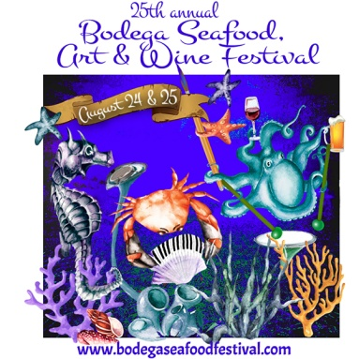
FESTIVAL FOOD APPLICATION 2019
Fill out this application and email it back to us as an attachment. You can also print a copy and mail it in with your payment, but please email it to us as well. Please include 1 image of your food and 1 of your display. Images can be mailed or emailed with your application.
FOR OFFICE USE ONLY
JURY FEE PAID:
BOOTH FEE PAID:
check # credit card
AMOUNT: DATE:
ACCEPT DECLINE
CORNER DBL
BOOTH ASSIGNMENT:

Booth fee and App fee are due with application. Booth fee checks are not cashed until 2 weeks after acceptance. If you would like to use a credit card please email us to invoice you.
First Name: Last Name:
Company Name:
Address: City, State, Zip:
Phone: Email:
PLEASE ATTACH MENU.
BOOTH FEES PLEASE CIRCLE DESIRED BOOTH SIZE
HOT ENTRÉE FOOD VENDORS
FIRST DEADLINE (before 4/15): 10w x 15d $750 / 20w x 15d $1450
SECOND DEADLINE (4/15-5/15): 10w x 15d $800 / 20w x 15d $1550
NON ENTRÉE FOOD VENDORS (desserts, etc):
FIRST DEADLINE: (before 4/15): 10w x 15d $475 / double booth $775
SECOND DEADLINE: (4/15-5/15): 10w x 15d $525 / double booth $1025
Corner booth for food vendors: $100 extra (separate check)
There are very few corners in the food area and we will give them out based on application date,
so apply early if you want one!
APPLICATION FEE: $20 FOR ALL APPLICANTS
BOOTH SPACE REQUEST_________________________________________________________
WOULD YOU LIKE FESTIVAL POSTCARDS? Yes___ No____ IF SO HOW MANY?___________
I HAVE READ (on website page) AND AGREE TO ALL THE TERMS PUT FORTH IN THIS APPLICATION:
SIGNATURE (typed is fine) DATE
EMAIL TO: info@bodegaseafoodfestival.com In the subject line please put “application: your name.”
MAIL HARD COPY WITH CHECK, OR HAVE US INVOICE YOU TO PAY BY CREDIT/DEBIT CARD.
BOOTH LOCATION IS BASED ON APP AND PAYMENT DATE.

