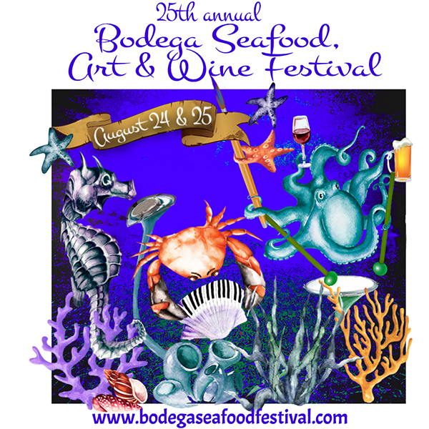
25th annual BODEGA SEAFOOD, ART & WINE FESTIVAL
AUGUST 24 & 25, 2019

SPONSORSHIP PARTICIPATION FORM

COMPANY NAME____________________________________________________________________
CONTACT NAME_______________________________________________ _____________________
ADDRESS___________________________________________________________________________
CITY, STATE, ZIP_____________________________________________________________________
PHONE_____________________________________________________________________________
EMAIL____________________________________________________________ _________________
WEBSITE____________________________________________________________________________

WE WOULD LIKE TO SPONSOR THE FESTIVAL!
LEVEL OF SPONSORSHIP:
_____PRESENTING: $10,000
_____TOP LOBSTER: $5,000
_____HAPPY HALIBUT: $3,000
_____TERRIFIC TUNA (BOOTH ONLY): 10x10: $1,000 ______10x20: $1750
_____CORNER BOOTH $100 extra
_____IN-KIND (PLEASE DESCRIBE):

_____SPECIAL PACKAGE. WE NEED THE PACKAGE TO INCLUDE:
(FOR SPECIAL SPONSORSHIPS WE WILL DISCUSS COST WITH YOU)
PLEASE EMAIL THIS FORM TO: wcfestivals@sbcglobal.net. When I receive it I will issue a sponsor agreement and an invoice. Sponsorship fees due 60 days prior to festival.|
All festival information, including booth space assignments, parking passes, etc., will be both mailed and emailed approximately 1 month prior to the festival. If you have any questions please contact me: Janet Ciel 707 824-8717 / 529-4884 wcfestivals@sbcglobal.net
Thank you so much!

