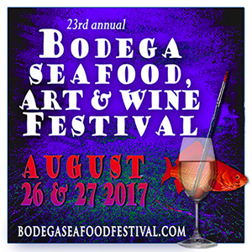
23rd annual
Bodega Seafood, Art & Wine Festival
August 26 & 27, 2017
Watts Ranch 16855 Bodega Hwy, Bodega CA
Wine, Microbrew and Cider Tasting 2017

Tasting Participation Form:
PLEASE FILL THIS OUT AND SAVE WITH THE NAME “TASTING PARTICIPATION: (name of company) .”
Email it as an attachment to: wcfestivals@sbcglobal.net
You can also mail to BSAWF P.O. Box 1862 Sebastopol, CA 95473
YES WE WANT TO PARTICIPATE IN THE FESTIVAL TASTING!

COMPANY NAME:

CONTACT NAME:
ADDRESS:

CITY, STATE, ZIP:

PHONE:
EMAIL:

WEBSITE:

Thank you so much and we look forward to seeing you at the festival!
CONTACT: JANET CIEL 707 824-8717 707 529-4884(cell)
wcfestivals@sbcglobal.net
www.bodegaseafoodfestival.com

