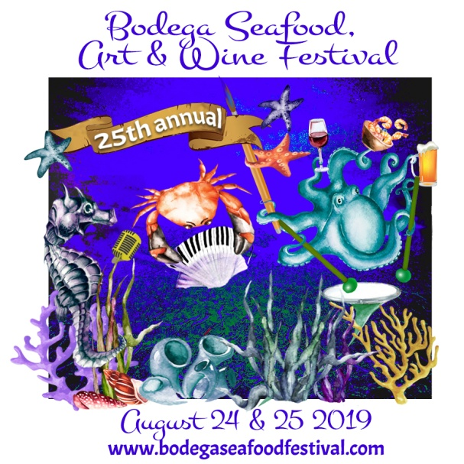
25th annual
Bodega Seafood, Art & Wine Festival
August 24 & 25, 2019
Watts Ranch 16855 Bodega Hwy, Bodega CA
Wine, Microbrew and Cider Tasting 2019
Tasting Participation Form:
PLEASE FILLTHIS IN USING WORD AND SAVE WITH THE NAME
“TASTING PARTICIPATION: (name of company) .”
Email it as an attachment to: wcfestivals@sonic.net
You can also mail to BSAWF P.O. Box 1862 Sebastopol, CA 95473
YES WE WANT TO PARTICIPATE IN THE FESTIVAL TASTING!

COMPANY NAME:
CONTACT NAME:
ADDRESS:
CITY, STATE, ZIP:
PHONE:
EMAIL:
WEBSITE:
WE ARE INTERESTED IN SELLING OUR PRODUCT: yes no
(You’ll receive full information in early July, as well as another form to fill in which will ask you the schedule you’d like to pour. This form just lets us know you’re in! )
Thank you so much and we look forward to seeing you at the festival!
CONTACT: JANET CIEL 707 824-8717 707 529-4884(cell)
wcfestivals@sbcglobal.net
www.bodegaseafoodfestival.com

